Can you carry out research about an animal of your choice and create a fact page? (Like we did about hedgehogs in school).

Think about these questions when you are writing your facts:

What animal group does it belong to? (mammal, bird, fish, reptile, amphibian)
Why does it belong to that group? What does it look like?

What animal group does it belong to depending on what it eats? (carnivore, omnivore, herbivore)
How do you know it belongs to that group?

What is this animal’s habitat?

What is this animal’s babies called?

What is a group of this animal called?

Are the males and females of your animal called different names?

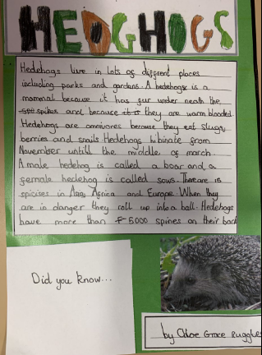
This is an example of a hedgehog fact page we did in school earlier this year. You can use this to inspire you to create your own fact page. Feel free to create your fact page on Word Document or create a PowerPoint about your animal instead.

When you have finished if you can upload them to Tapestry it would be lovely for us to see them.

