- Can you order the lengths of time from the shortest to the longest?
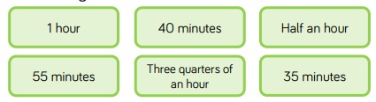

- Look at the table below and complete the sentences.
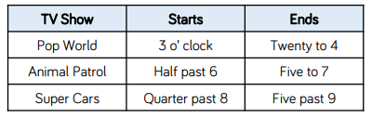

____________ is the shortest TV show.
____________ is longer than __________ and ____________ .

- Use the symbols < > = to compare the durations of time below.
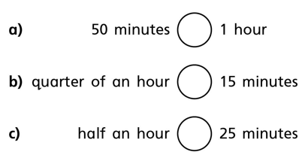

- Teddy and Ron tidied their bedrooms. The clocks show the time they started and the time they finished.
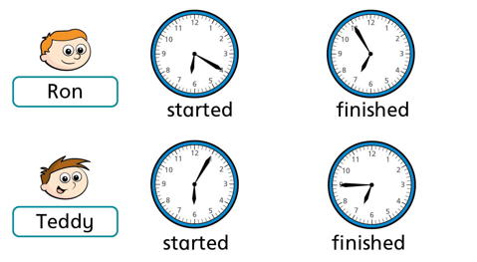

- Who tidied their room in the least amount of time?
- How did you work this out?

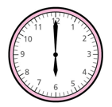
- Aisha and Kim both started their homework at 6 o’clock. Aisha finished her homework at 25 past 6.
Kim’s homework took her 10 minutes longer.
What time did Kim finish her homework?

- Rosie has 1 hour for her lunch break.
If she takes 10 minutes to eat her lunch, will she have enough time to complete all of the outdoor activities?

