Year 2 Reading Comprehension
Food chains
Useful words: energy, caterpillar, predators
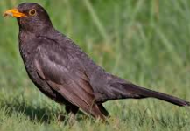
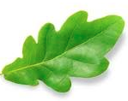
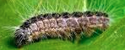
I am in the middle of this food chain. I love munching on tasty leaves like this crispy oak leaf. In fact, I spend a lot of my life eating! However, I need to be careful and keep a look out for predators. Although some birds ignore me, there are some scarier birds like this blackbird who will eat me if they see me! This food chain shows how I pass energy from the Oak leaf all the way up to the blackbird.
Oak leaf Caterpillar Blackbird

I am at the end of this food chain and some people would call me a predator. However, this is not where it ends for me because the energy I get from the caterpillar is then given to the animal that eats me! I need to stay away from larger birds like the sparrow hawk and from foxes! I eat juicy caterpillars and other wriggly insects like worms, snails and slugs. I do sometimes eat the occasional berry which makes me an omnivore.

- Find and copy one word that means ‘chomping’.
- How does a caterpillar gain energy?
- Why do caterpillars need to be careful?
- What word could the author have used instead of ‘crispy’?
- How do you think a caterpillar feels when they see a blackbird?
- In this text, what does the word predator mean?
- What animals tend to hunt blackbirds?
- Name 3 things that a blackbird likes to eat?

