Today we will be learning about hours and days.
I wonder if you already know how many hours there are in a day… or how many minutes there are in one hour…
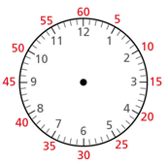
Use the clock face to help you complete the stem sentences (count around the clock face in 5’s)

There are _____ minutes in one hour
There are _____ minutes in half an hour
There are _____ minutes in quarter of an hour
There are _____ minutes in 1 hour and a half

Can you match the time in minutes to the time in hours and minutes?
(Use a clock to help you and remember to count in multiples of 5).

90 minutes
60 minutes
75 minutes
120 minutes
70 minutes
1 hour
1 hour and 30 minutes
2 hours
1 hour and 10 minutes
1 hour and 15 minutes

How many hours are there in 1 day?
From 12 o’clock (midnight), can you count how many hours there are in a full day? You can use the clock faces below to help you by drawing each hour.
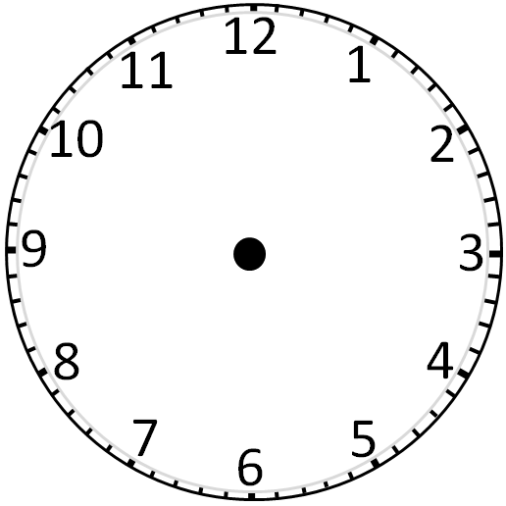

There are _____ hours in 1 full day

The bar model shows a day in the life of Dexter.
Can you use the bar model to answer the questions below?
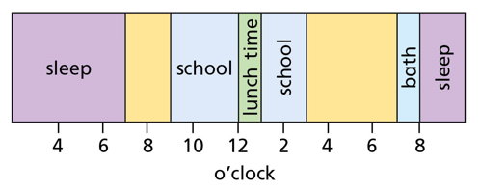
- What time does Dexter do to sleep?

- What time in the morning does Dexter wake up?

- What do you think Dexter might do between 7 o’clock and 9 o’clock in the morning?

- What do you think Dexter could be doing at 6 o’clock in the evening?

Challenge
Can you create your own bar model showing what you do in a typical day?
You may want to use a school day if this is easier.

