Today we would like you to have a go at writing the time shown on each clock.

Ask yourself:

Is it **past or to** the hour?

Where is the **minute hand** pointing?

Where is the **hour hand** pointing?

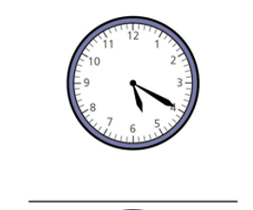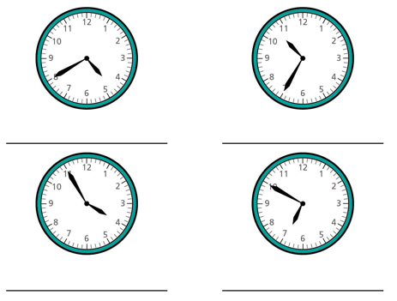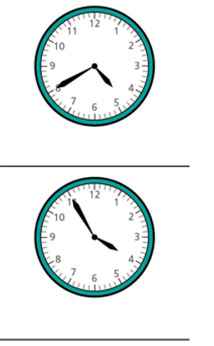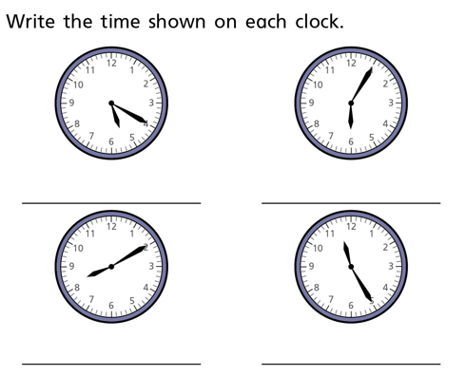

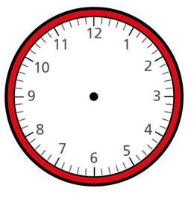Can you draw the hands **accurately** to show these times?

25 past 3

10 to 11

5 past 1

20 to 6

Problem solving and reasoning challenges

