There are 60 minutes in 1 hour (one full turn of the minute hand around the clock is one hour)
There are 5 minutes between each number on the clock face.
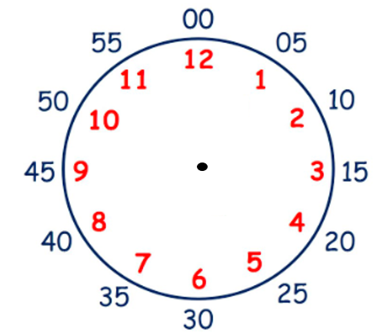
Have a go at counting in 5’s around the clock face, starting at 12 as 0 (point to each number as you count).

We must remember that the minute hand ALWAYS moves clockwise around the clock face. The first half of the clock face is ‘past’ the hour. The second half of the clock face is ‘to’ the hour. When we tell the time ‘to’ the hour we count backwards in 5’s
(see below and practice counting this way).
O’clock
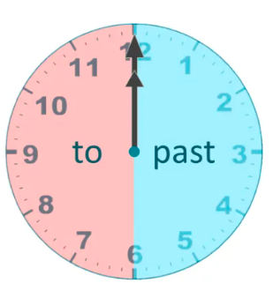
5 to
10 to
15 to (quarter to)
20 to
25 to
5 past
10 past
15 past (quarter past)
20 past
25 past

Half past

Activity 1
Can you sort these times into two groups: past the hour and to the hour?
(You could cut and stick the times into the correct group or verbally explain how you know to a member of your family).

Past the hour | To the hour
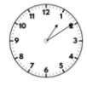
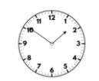
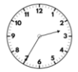
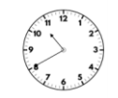
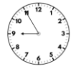
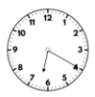

Activity 2
Have a go at completing the table below. What do you notice?
How does the minute hand move around the clock face?
Can you remember how many minutes there are in between each number?
It would be great if you could make these times on an analogue clock if you have one at home. If not you could make use of the interactive clock on topmarks.
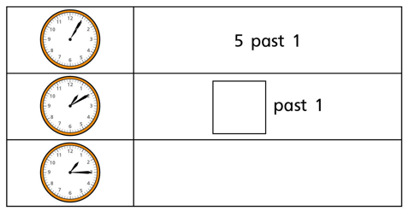
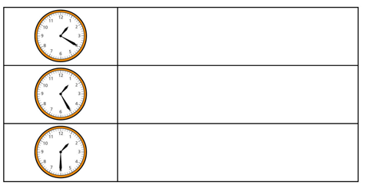

What would happen if this pattern continued? Have a go at writing down the time that would come next (would it still be ‘past’ the hour?)
You could explore this concept of time passing with a different hour – start at 6 o’clock and have a go at making your own list of times within the hour. I have started this for you…
6 o’clock
5 past 6 …

