Time Quiz!
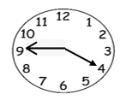
Can you tell the times on each clock?
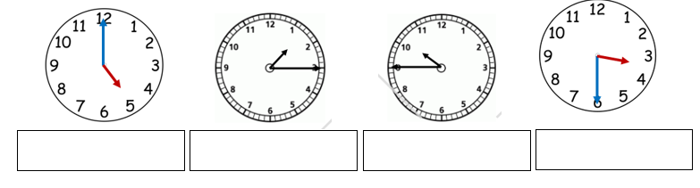
Jake says he has shown the time quarter to 4 on his clock.
Is he correct? How do you know?

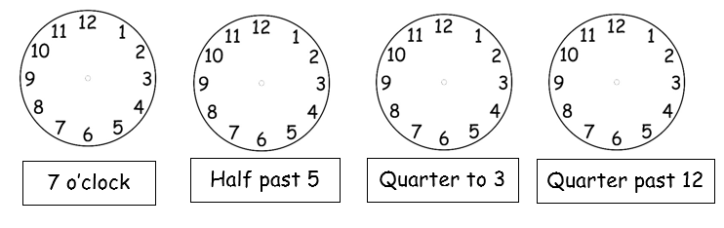
Can you show these times on the clocks? (Think about the size and position of the hands)

